BHARTIA & ASSOCIATES
Proprietor
Shyam Sundar Bhartia
B.E.,MIE.,FIV,FIISA,FICA, AIII. OFFICE :
CHARTERED ENGINEER (INDIA) 308, VARMA CENTRE, BORING ROAD CROSSING,
GOVT. REGD. & APPROVED VALUER PATNA – 800001 (BIHAR)
(Under Wealth Tax Act, Income Tax Valuer) Ph. : 2540409 (O), Mob. : 9431011782

Registration No. : CAT – 1/138 of 1998 – 99. Email ID : shyambhartia2012@gmail.com

Ref No. : B&A/2021 – 2022/UCO/ASH/AMT/ Date: 13.09.2021.

TO

UCO BANK

MAIN BRANCH BANKA.

VALUATION REPORT
(IN RESPECT OF LAND/SITE AND BUILDING )
( To be filled in by the Approved Valuer )
M/s Arya Traders change karna hai
[CC LOAN UCO TRADERS A/C No.- 17990510003305] change karna hai

I. | GENERAL
1. | Purpose for which the Opinion is made |  |  |  |  |  |  |  |  |  | : | To assess the present market value for Collateral Securities to UCO, MAIN BRANCH BANKA.
2. | a. | Date of inspection |  |  |  |  |  |  |  |  | : | 10.09.2021.
2. | b. | Date on Which the Opinion is made |  |  |  |  |  |  |  |  | : | 13.09.2021.
3. | List of documents Produced for Perusal
 | 1) Sale Deed |  |  |  |  |  |  |  |  |  | : | Sale Deed.- 3259 Dated.- 16.03.2015.
 |  |  |  |  |  |  |  |  |  |  | : | Sale Deed.- 3309 Dated.- 17.03.2015.
 | 3) Rent Receipt |  |  |  |  |  |  |  |  |  | : | Rent Receipt No.- X/106-00775138 Dated.- 14.10.2016.
 | 4) LPC |  |  |  |  |  |  |  |  |  | : | LPC No.- 424 Dated.-08.02.2017.
4. | Name of the Owner(s) and his/their address(es) with Phone no. (details of share of each owner in Case of joint ownership) |  |  |  |  |  |  |  |  |  | : | Smt Kalpana Devi  W/o Sri Sanjay Prasad Yadav  At.- Bhagalpur Hasdiha Main Road Dhaka More Near MACPY College Dhaka & Dhaka more Golambar, P.O.- Dhaka More, P.S..- Banka, Mauza.- Dhaka, Thana No.- 51, Distt.- Banka (Bihar), Pin Code.- 813102. Mob.- 9955080535.
5. | Brief description of the Property (Including leasehold/freehold etc.) |  |  |  |  |  |  |  |  |  | : | Property Under Consideration is Land & B+G+4 Floor Six Story Building. Ground Floor is used for commercial shop, 1st to 3rd Floor is used for JITM Skills Pvt Ltd. (Pradhan Mantri kaushal Kendra) This Property is already mortgaged in the bank. The Said Property is Bounded in Two Sale Deed.
6. | Location of Property
6. | a) |  | Plot No. / Survey No. |  |  |  |  |  |  |  | : | 554, 575 Ke Mi.
6. | b) |  | Khata No. |  |  |  |  |  |  |  | : | 8.
6. | c) |  | Mohallah. |  |  |  |  |  |  |  | : | Dhaka More.
6. | d) |  | Mauza |  |  |  |  |  |  |  | : | Dhaka.
6. | e) |  | Thana No. |  |  |  |  |  |  |  | : | 51.
6. | f) |  | Jamabandi No |  |  |  |  |  |  |  | : | 1119.
6. | g) |  | Anchal / District |  |  |  |  |  |  |  | : | Banka / Banka (Bihar).
7. | Postal address of the Property |  |  |  |  |  |  |  |  |  | : | At.- Bhagalpur Hasdiha Main Road Dhaka More Near MACPY College Dhaka & Dhaka more Golambar, P.O.- Dhaka More, P.S..- Banka, Mauza.- Dhaka, Thana No.- 51, Distt.- Banka (Bihar), Pin Code.- 813102.
8. | City / Town |  |  |  |  |  |  |  |  |  | : | Dhaka More Banka
8. | Residential Area |  |  |  |  |  |  |  |  |  | : | Yes
8. | Commercial Area |  |  |  |  |  |  |  |  |  | : | Yes.
8. | Industrial Area |  |  |  |  |  |  |  |  |  | : | No
9. | Classification of the Area
9. | 1) |  | High/Middle /Poor |  |  |  |  |  |  |  | : | Middle.
9. | 2) |  | Urban /Semi Urban /Rural |  |  |  |  |  |  |  | : | Rural.
10. | Coming Under Corporation limit/Village Panchayat /Municipality |  |  |  |  |  |  |  |  |  | : | Village Panchayat Area.
11. | Whether Covered under any State /Central Govt. enactments (e.g. Urban Land Ceiling Act) or notified under agency area / Scheduled area / cantonment area |  |  |  |  |  |  |  |  |  | : | No.
12 | In Case it is an agriculture land, any conversion to house site Plots is Contemplated |  |  |  |  |  |  |  |  |  | : | No.
13. | Boundaries of the Property
13. | Deed No 3259↓ As per Deed No 3309↓ |  |  |  |  |  |  |  |  |  |  | As per Actual ↓
13. | North |  |  | Nij Purchaser |  |  |  | Nij Purchaser |  |  | N | Nij Purchaser
13. | South |  |  | Rajesh Kumar Jha |  |  |  | Md Akram |  |  | S | Md Akram
13. | East |  |  | Colony Road 16’feet |  |  |  | 16’ feet Rasta |  |  | E | Colony Road 16’feet
13. | West |  |  | Main Road Bhagalpur - Dumka |  |  |  | Sarak. |  |  | W | Main Road Bhagalpur – Dumka
14. | Dimension of the Site |  |  |  |  |  |  |  |  |  | : | A |  |  |  | B
14. |  |  |  |  |  |  |  |  |  |  | : | As per the Deed |  |  |  | Actual
14. | North |  |  |  |  |  |  |  |  |  | : |  |  |  |  | 108’00’’
14. | South |  |  |  |  |  |  |  |  |  | : |  |  |  |  | 108’00’’
14. | East |  |  |  |  |  |  |  |  |  | : |  |  |  |  | 60’00’’
14. | West |  |  |  |  |  |  |  |  |  | : |  |  |  |  | 60’00’’
14.2 | Latitude ,Longitude and Coordinates of the site |  |  |  |  |  |  |  |  |  | : | 24°54'02.8"N 86°59'54.4"E  24.900766, 86.998440
15. | Extent of the Site |  |  |  |  |  |  |  |  |  | : | 2177.60 Sq. Ft. = 5 Decimal deed 3259  4355.20 Sq. Ft. = 10 Decimal deed 3309  6532.80 Sq. Ft. = 15 Decimal
16. | Extent of the Site Consider For Opinion (Least of 14 A& 14 B) |  |  |  |  |  |  |  |  |  | : | 15 Decimal.
17. | Whether occupied by the owner / tenant ? if occupied by tenant, Since how Long? Rent received Per month. |  |  |  |  |  |  |  |  |  | : | Owner
18. | Whether necessary enquiries have been made from the concerned locality with regard to the ownership of the property (Sri / Ms) of the locality was contacted) |  |  |  |  |  |  |  |  |  | : | Sri rajesh Kumar  Mobile No. – 9892231703.  Sri Dipesh.  Mobile No. – 7903144401.
11. | CHARACTERISTICS OF THE SITE
1. | Classification of locality |  |  |  |  |  |  |  |  |  | : | Middle.
2. | Development of Surrounding areas |  |  |  |  |  |  |  |  |  | : | Developing.
3. | Possibility of frequent flooding /sub merging |  |  |  |  |  |  |  |  |  | : | No.
4. | Feasibility to the civic amenities like school ,hospital, bus stop , market etc. |  |  |  |  |  |  |  |  |  | : | All About 8 Km.
5. | Level of land With Topographical Conditions |  |  |  |  |  |  |  |  |  | : | Below Road Level.
6. | Shape of Land |  |  |  |  |  |  |  |  |  | : | Rectangular.
7. | Type of use to which it can be Put |  |  |  |  |  |  |  |  |  | : | Residential. Cum Commercial.
8. | Any Usage restriction |  |  |  |  |  |  |  |  |  | : | No.
9. | Is Plot in Town Planning Approved Layout? |  |  |  |  |  |  |  |  |  | : | No.
10. | Corner Plot or Intermittent Plot? |  |  |  |  |  |  |  |  |  | : | Intermittent Plot
11. | Road Facilities |  |  |  |  |  |  |  |  |  | : | Yes.
12. | Type of Road Available |  |  |  |  |  |  |  |  |  | : | RCC Road.
13. | Width of road – is it below 45 ft. or more than 45 ft. |  |  |  |  |  |  |  |  |  | : | Below then 45 ft.
14. | Is it a land – locked land? |  |  |  |  |  |  |  |  |  | : | No.
15. | Water potentiality |  |  |  |  |  |  |  |  |  | : | Available.
16. | Underground sewerage system |  |  |  |  |  |  |  |  |  | : | Not Available.
17. | Is power supply available at the site? |  |  |  |  |  |  |  |  |  | : | Available.
18. | Advantage of the site
 | 1. |  |  |  |  |  |  |  |  |  | : | Developing residential area very near 100 Mtr  To MACPY College Dhaka & Dhaka more Golambar Banka.
 | 2. |  |  |  |  |  |  |  |  |  | : | Suitable For Residential Cum Commercial Purpose.
19. | Special remarks, if any, like threat of acquisition of land for public service purposes, road widening or applicability of CRZ provisions etc. (Distance from sea-coast / tidal level must be incorporated |  |  |  |  |  |  |  |  |  | : | No..
 | 1. |  |  |  |  |  |  |  |  |  | : | No.
 | 2. |  |  |  |  |  |  |  |  |  | : | No
Part – A (Valuation of Land )
1. | Size of Plot
1. | North & South |  |  |  |  |  |  |  |  |  | : | 108’00’’ |  |  |  |  | 108’00’’
1. | East & West |  |  |  |  |  |  |  |  |  | : | 60’00’’ |  |  |  |  | 60’00’’
2. | Total extent of the plot |  |  |  |  |  |  |  |  |  | : | 15 Decimal.
3. | Prevailing market rate (Along with details /reference of at least two latest deals/transactions with respect to adjacent properties in the areas) |  |  |  |  |  |  |  |  |  | : | Rs. 3,50,000 To 4,00,000 Per Decimal.
4. | Guideline rate obtained from the Registrar’s Office (an evidence thereof to be enclosed) |  |  |  |  |  |  |  |  |  | : | Rs. 2,00,000 Per Decimal.
5. | Assessed/ adopted rate of Opinion |  |  |  |  |  |  |  |  |  | : | Rs. 3,50,000 Per Decimal.
6. | Estimate Value of Land |  |  |  |  |  |  |  |  |  | : | PMR : 15 X 3,50,000 = Rs. 52,50,000.
Part – B (Valuation of Building )
1. | Technical Details of the building
 | a) |  | Type of Building (Residential/Commercial/Industrial) |  |  |  |  |  |  |  | : | Residential Cum Commercial
 | b) |  | Type of Construction ( Load Bearing /RCC/Steel Framed ) |  |  |  |  |  |  |  | : | RCC.
 | c) |  | Year of construction |  |  |  |  |  |  |  | : | B+G+4thFloor 2017.
 | d) |  | Number of floors and height of each floor including basement, if any |  |  |  |  |  |  |  | : | Basement - Height- 8’  G+4thFloor - Height- 11,
 | e) |  | Plinth area floor-wise |  |  |  |  |  |  |  | : | GF.- 6100 Sq. Ft. 1stF.- 6100 Sq. Ft.  2ndF.- 6100 Sq. Ft. 3rdF.- 6100 Sq. Ft.  4thF.- 6100 Sq. Ft.
 | f) |  | Condition of the building
2. | 1. |  | Exterior - Excellent , Good, Normal , Poor |  |  |  |  |  |  |  | : | Good
2. | 2. |  | Inferior – Excellent ,Good ,Normal ,Poor |  |  |  |  |  |  |  | : | Good
3. | Date of Issue and Validity of Layout of approved map/Plan |  |  |  |  |  |  |  |  |  | : | No.
4. | Approved map / plan issuing authority |  |  |  |  |  |  |  |  |  | : | No.
5. | Whether genuineness or authenticity of approved map / plan is verified |  |  |  |  |  |  |  |  |  | : | No.
6. | Any other comments by our empanelled valuers on authentic of approved plan |  |  |  |  |  |  |  |  |  | : | No.
Specifications of Construction (floor-wise) in respect of
S. No. | Description |  |  |  |  |  |  |  |  |  | : | Ground Floor |  |  |  | Other floors
1. | Foundation |  |  |  |  |  |  |  |  |  | : | Pile Foundation |  |  |  | -------------
2. | Basement |  |  |  |  |  |  |  |  |  | : | Available |  |  |  | ----------------
3. | Superstructure |  |  |  |  |  |  |  |  |  | : | 1st Class Rcc |  |  |  | 1st Class Rcc
4. | Joinery / Doors & Windows (please furnish details about size of frames, shutters, glazing, fitting etc. and specify the species of timber) |  |  |  |  |  |  |  |  |  | : | Wooden Door Window &  Iron Gate & Grill |  |  |  | Wooden Door Window &  Iron Gate & Grill
5. | RCC works |  |  |  |  |  |  |  |  |  | : | 1:2:3 CM |  |  |  | 1:2:3 CM
6. | Plastering |  |  |  |  |  |  |  |  |  | : | Done |  |  |  | Done
7. | Flooring, Skirting, dadoing |  |  |  |  |  |  |  |  |  | : | Done |  |  |  | Done
8. | Special finish as marble, granite, wooden paneling, grills, etc. |  |  |  |  |  |  |  |  |  | : | IPS Flooring |  |  |  | Verified Tiles Flooring
9. | Roofing including weather proof course |  |  |  |  |  |  |  |  |  | : | Only Roof |  |  |  | Only Roof
10. | Drainage |  |  |  |  |  |  |  |  |  | : | Available through PVC Pipe |  |  |  | Available through PVC Pipe
11. | Area supported by documentary proof, Shape, dimensions and physical features |  |  |  |  |  |  |  |  |  | : | Photographs.
12. | What was the method of construction by contract by employing labor / directly / both |  |  |  |  |  |  |  |  |  | : | Both.
13. | No. of lifts and capacity |  |  |  |  |  |  |  |  |  | : | No.
14. | Underground pump - Capacity and Type of Construction |  |  |  |  |  |  |  |  |  | : | 1 HP Samursable.
15. | Overhead Tank
15. | a) Where Located |  |  |  |  |  |  |  |  |  | : | Top of the Building
15. | b) Capacity |  |  |  |  |  |  |  |  |  | : | 3000 Ltr.
15. | c) Type of Construction |  |  |  |  |  |  |  |  |  | : | Plastic Tank.
16. | Water Pumps - Number & their horse power |  |  |  |  |  |  |  |  |  | : | 1 HP Samursable
17. | Roads & paving within the compound, Approximate area & type of paving |  |  |  |  |  |  |  |  |  | : | N.A.
18. | What is the floor space index permissible and percentage actually utilized? |  |  |  |  |  |  |  |  |  | : | N.A.
19. | Estimated Future Life |  |  |  |  |  |  |  |  |  | : | 77 Years.
20. | Is it freehold or leasehold land? |  |  |  |  |  |  |  |  |  | : | Free Hold.
21. | If leasehold, the name of Lessor / Lessee, nature of lease, dates of commencement / termination of lease and terms of renewal of lease. |  |  |  |  |  |  |  |  |  | : | N.A.
21. | a) Initial premium |  |  |  |  |  |  |  |  |  | : | N.A.
21. | b) Ground rent payable p.a. |  |  |  |  |  |  |  |  |  | : | N.A.
21. | c) Unearned increase payable to the lessor in the event of sale or transfer |  |  |  |  |  |  |  |  |  | : | N.A.
21. | d) Are there any agreements of lease meant ? If so, attach copies |  |  |  |  |  |  |  |  |  | : | N.A.
22. | a) Does the land fall in an area included in any Town planning scheme or any development plan of Govt. or any statutory body? If so, given particulars. |  |  |  |  |  |  |  |  |  | : | N.A.
22. | b) has any contribution been made towards development or is any demand for such contribution still outstanding. |  |  |  |  |  |  |  |  |  | : | N.A.
23. | Is the building owner-occupied, specify portion and extent of area under owner occupation. |  |  |  |  |  |  |  |  |  | : | Owner Occupied.
23. | a) Name of tenants / lessees / licensees etc. |  |  |  |  |  |  |  |  |  | : | N.A.
23. | b) Portions in their occupations |  |  |  |  |  |  |  |  |  | : | N.A.
23. | c) Monthly or annual rent / compensation / license fee etc. paid by each |  |  |  |  |  |  |  |  |  | : | N.A.
23. | d) Gross amount received for whole property |  |  |  |  |  |  |  |  |  | : | N.A.
23. | e) Are any of the occupants related to or close business associates of the owner. |  |  |  |  |  |  |  |  |  | : | N.A.
24. | Is the building insured, if so, give the policy no. Amount for which it is insured and annual premium. |  |  |  |  |  |  |  |  |  | : | N.A.
25. | Has any standard rent been fixed for the premises under any law relating to the control of rent? |  |  |  |  |  |  |  |  |  | : | N.A.
26. | Is any dispute between landlord and tenant regarding rent pending in a court of law? |  |  |  |  |  |  |  |  |  | : | N.A.
27. | Whether possession of the property can be taken by the bank in case of need without any litigation (society rules, independent entrance, co-owner's share/joint ownership etc.) |  |  |  |  |  |  |  |  |  | : | Yes.
S. No. | Description |  |  |  |  |  |  |  |  |  | : | Ground floor |  |  |  | Other floors
1. | Compound wall |  |  |  |  |  |  |  |  |  | : | No.
 | a) |  |  | Height |  |  |  |  |  |  | : | ----------
 | b) |  |  | Length |  |  |  |  |  |  | : | -------
 | Type of Construction |  |  |  |  |  |  |  |  |  | : | -------
2. | Electrical installation
 | a) |  |  | Type of Wiring |  |  |  |  |  |  | : | Under Ground
 | b) |  |  | Class of Fittings (Superior /Ordinary /Poor) |  |  |  |  |  |  | : | Superior.
 | c) |  |  | Number of light Points |  |  |  |  |  |  | : | 50 Nos.
 | d) |  |  | Fan Points |  |  |  |  |  |  | : | 20 Nos.
 | e) |  |  | Share Plug Points |  |  |  |  |  |  | : | 20 Nos.
 | f) |  |  | Any Other item |  |  |  |  |  |  | : | N.A
3. | Plumbing installation
 | a) |  |  | No. of water closets and their type |  |  |  |  |  |  | : | N.A
 | b) |  |  | No. of wash basins |  |  |  |  |  |  | : | 01 Nos.
 | c) |  |  | No. of Urinals |  |  |  |  |  |  | : | 01 Nos
 | d) |  |  | No. of bath tubs |  |  |  |  |  |  | : | N.A
 | e) |  |  | Water meter, taps ,etc. |  |  |  |  |  |  | : | N.A
 | f) |  |  | Any other fixtures |  |  |  |  |  |  | : | N.A
Details of Building
S.  N. | Particulars  of  Item |  |  |  | Plinth Area  Sq. Ft. | Roof Ht. | Age of Building |  |  | Estimated replacement rate of construction  Rs. |  |  |  | Replacement Cost  Rs. | Depreciation  Rs. |  |  | Net Value after depreciation  Rs.
1 | Basement |  |  |  | 6100 | 08’ | 03 Yrs |  | Rs. 1000 per Sq. Ft. |  |  |  | 61,00,000. |  | 2,05,875. |  |  | 58,94,125.
2 | Ground Floor |  |  |  | 6100 | 11’ | 03 Yrs |  | Rs. 1100 per Sq. Ft. |  |  |  | 67,10,000. |  | 2,26,462. |  |  | 64,83,537.
3 | 1st Floor |  |  |  | 6100 | 11’ | 03 Yrs |  | Rs. 1200 per Sq. Ft. |  |  |  | 73,20,000. |  | 2,47,050. |  |  | 70,72,950.
4 | 2nd Floor |  |  |  | 6100 | 11’ | 03 Yrs |  | Rs. 1200 per Sq. Ft. |  |  |  | 73,20,000. |  | 2,47,050. |  |  | 70,72,950.
5 | 3rd Floor |  |  |  | 6100 | 11’ | 03 Yrs |  | Rs. 1200 per Sq. Ft. |  |  |  | 73,20,000. |  | 2,47,050. |  |  | 70,72,950.
6 | 4th Floor |  |  |  | 6100 | 11’ | 03 Yrs |  | Rs. 1000 per Sq. Ft. |  |  |  | 61,00,000. |  | 2,05,875. |  |  | 58,94,125.
Total Rs. 3,94,90,637.
Part C – (Extra Items) (Amount in Rs.)
1. | Portico |  |  | : | N.A.
2. | Ornamental front door |  |  | : | N.A.
3. | Sit out/Verandah with steel grills |  |  | : | N.A.
4. | Overhead water tank |  |  | : | N.A.
5. | Extra steel/collapsible gates |  |  | : | N.A.
 | TOTAL |  |  | :
Part - D (Amenities) (Amount in Rs.)
1. | Wardrobes |  |  | : | N.A.
2. | Glazed Tiles |  |  | : | N.A.
3. | Extra sinks and bath tub |  |  | : | N.A.
4. | Marble/Ceramic tiles flooring |  |  | : | N.A.
5. | Interior decorations |  |  | : | N.A.
6. | Architectural elevation works |  |  | : | N.A.
7. | Paneling works |  |  | : | N.A.
8. | Aluminum works |  |  | : | N.A.
9. | Aluminum hand rails |  |  | : | N.A.
10. | False Ceiling |  |  | : | N.A.
 | TOTAL |  |  | :
Part E- (MISCELLANEOUS) |  |  | (Amount in Rs.)
1. | Separate toilet room |  |  | : | N.A
2. | Separate lumber room |  |  | : | N.A
3. | Separate water tank/sump |  |  | : | N.A
4. | Trees, gardening |  |  | : | N.A
 | TOTAL |  |  | :
Part F- (SERVICES) (Amount in Rs.)
1. | Water supply arrangements |  |  | : | N.A.
2. | Drainage arrangements |  |  | : | N.A
3. | Compound wall |  |  | : | N.A
4. | C.B. deposits, fittings, etc. |  |  | : | N.A
4. | Pilling & Plinth Level Work. |  |  | : | N.A
5. | Pavements |  |  | : | N.A
6. | Salvage |  |  | : | N.A
 | TOTAL |  |  | :

TOTAL ABSTRACT OF THE ENTIRE PROPERTY
PART – A | LAND | : | Rs. 52,50,000.
PART – B | BUILDING | : | Rs. 3,94,90,637.
PART – C | EXTRA ITEMS | : | Rs.
PART – D | AMENITIES | : | Rs.
PART – E | MISCELLANEOUS | : | Rs.
PART – F | SERVICES | : | Rs.
 | TOTAL | : | Rs. 4,47,40,637.
 | SAY | : | Rs. 4,47,41,000.

Valuation: Here the approved valuer should discuss in detail his approach (Market Approach, Income Approach and Cost Approach) to Valuation of property and indicate how the value has been arrived at, supported by necessary calculations. Also, such aspects as i) Salability ii) Likely rental values in future in iii) Any likely income it may generate, may be discussed)
Photograph of owner/representative with property in background to be enclosed. Yes
Screen shot of longitude/latitude and co-ordinates of property using GPS/Various Apps/Internet sites. Yes

As a result of my appraisal and analysis, it is my considered opinion that the present fair market value of the
above property in the prevailing condition with aforesaid specifications is Rs. 4,47,41,000.
(Rs. Four Caror Forty Seven Lakh Forty One Thousand Only).

The Realizable value of the above property is Rs. 4,02,66,900.
(Rs. Four Caror Two Lakh Sixty Six Thousand Nine Hundred Only).

and the distress value Rs. 3,62,40,210.
(Rs. Three Caror Sixty Two Lakh Forty Thousand Two Hundred Ten Only).

Assumptions / Remarks :
- Qualification in TIR/Mitigation suggested, if any : No
- Property is SARFAESI Complaint : Yes.
- Whether entire piece of land on which the unit is set up/property is situated has been mortgaged or to be mortgaged : Has Been Mortgaged in the bank.
- Whether property belongs to social infrastructure like hospital, school old age home etc. : No.
- Details of last two transaction in the locality/ area to be provided, if available : N.O.
- Any other aspect which has relevance on he value or marketability of the property : N.O

DECLARATION :

I, hereby declare that :

1. The Genuity of the title deeds & land records are to be confirmed / verified by the empanelled Advocate. The undersigned is not responsible for the same.

2. Value varies with the purpose and time. This report is not to be referred if the purpose is different other than mentioned in I (1). The property is identified by the bank & inspected in presence of Bank Officer.

3. The legal aspects were not considered in this valuation report. Any dispute subject to Patna Jurisdiction only.

4. This valuation work is undertaken by this valuer upon the request made by The Branch Manager, Uco Bank, Main Branch Banka in view of loan. “Identity of property owner should be property established by the banker before mortgage”

FOR BHARTIA & ASSOCIATES

PLACE : Patna SHYAM SUNDAR BHARTIA

DATE : 13.09.2021. Proprietor

GOVERNMENT REGD. VALUER
Registration No. : CAT-1/138 of 1998-99.
Panel Valuer of UCO Bank
Enclosures :
1. Photographs Duly Stamped.
2. Photocopy of Govt. Rate.
The undersigned have inspected the property detailed in the Valuation Report dated _________________ on _____________. We are satisfied that the fair and reasonable value of the property is _______________ (Rupees____________________________________
______________________________________ Only).
MANAGER

DATE :

Bhartia & Associates Route map of the plot of
Smt Kalpana Devi W/o Sri Sanjay Prasad Yadav
At.- Bhagalpur Hasdiha Main Road Dhaka More Near MACPY College Dhaka & Dhaka more Golambar, P.O.- Dhaka More, P.S..- Banka, Mauza.- Dhaka, Thana No.- 51, Distt.- Banka (Bihar), Pin Code.- 813102.
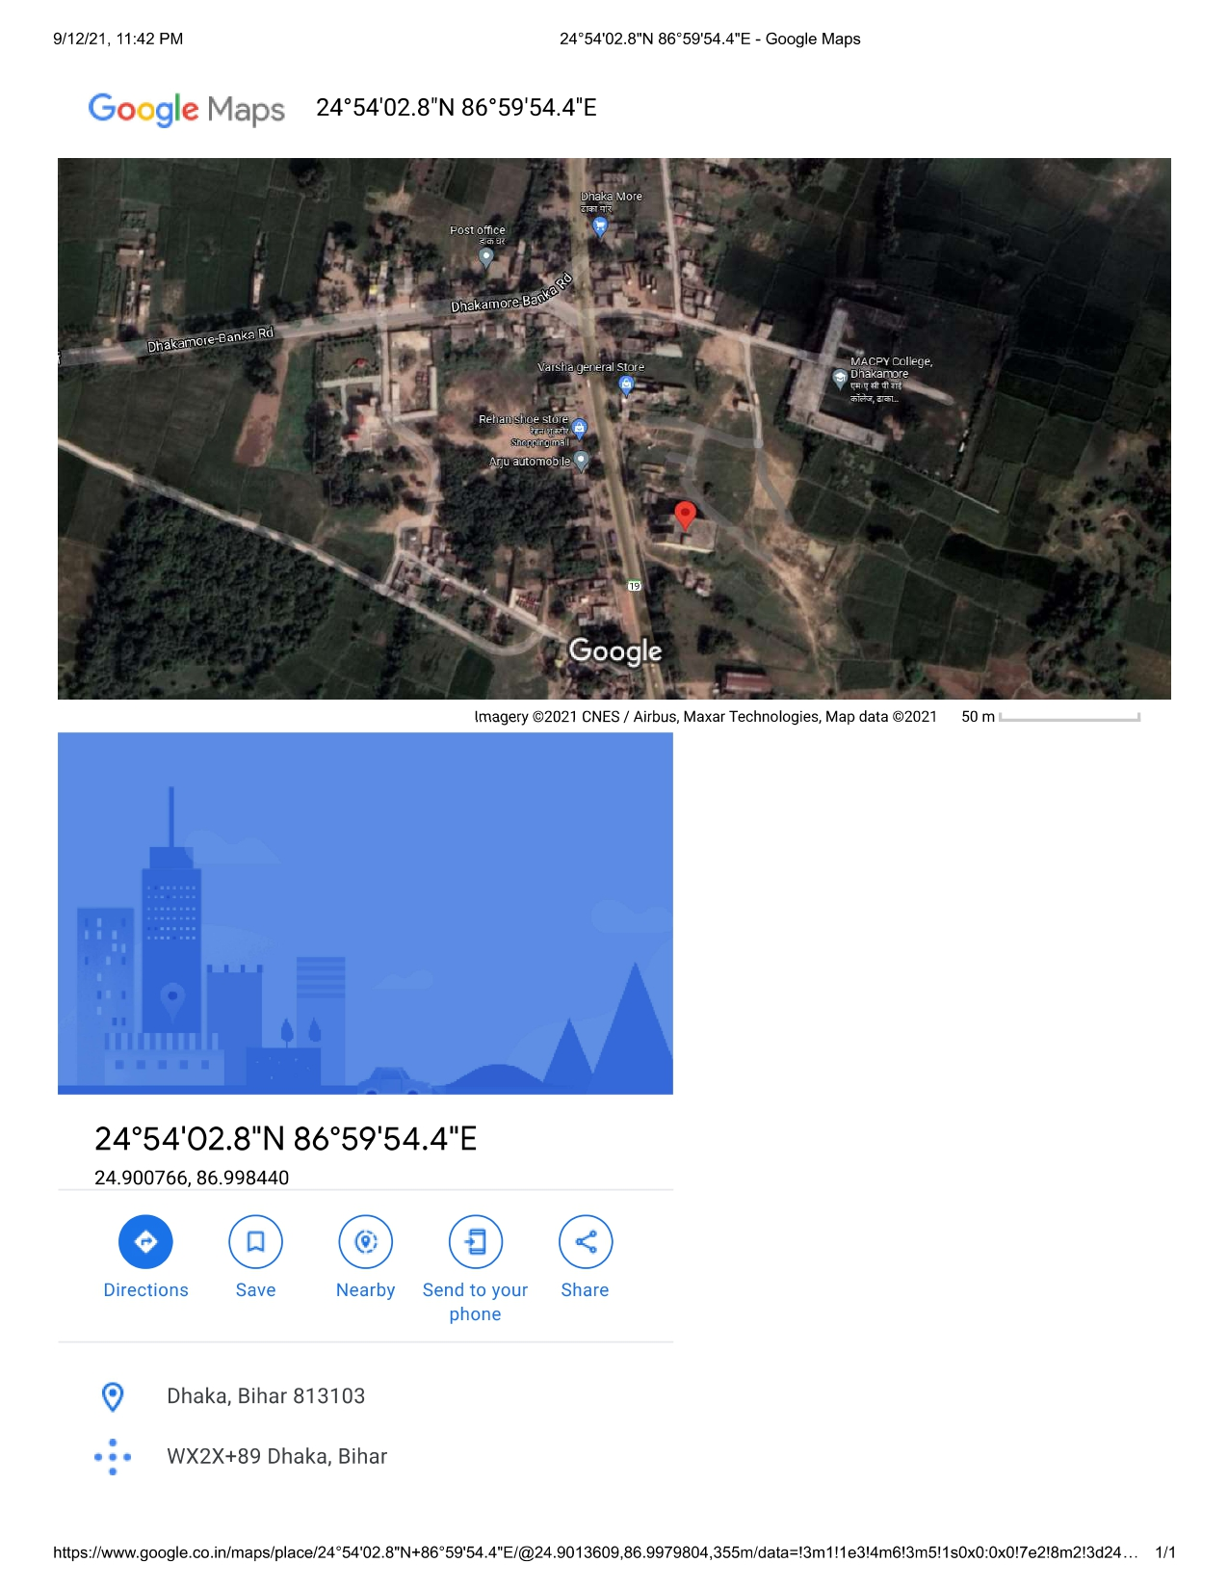
Bhartia & Associates Govt. Rate

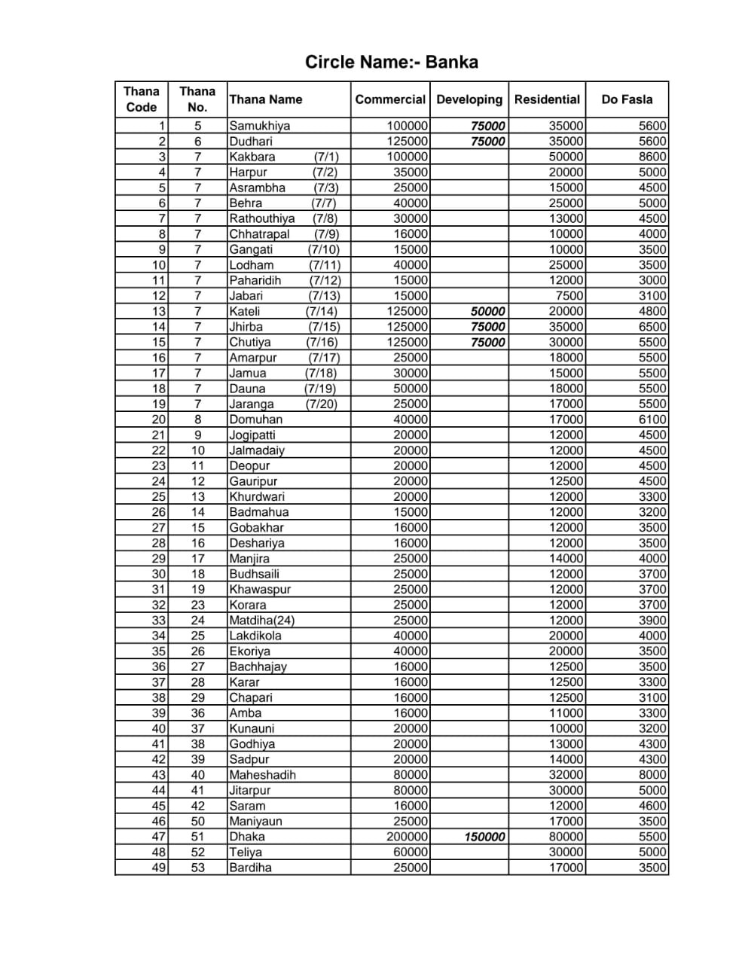
Bhartia & Associates Photograph of land & Building
